Ex16

import cv2
import matplotlib.pyplot as plt
from google.colab import files
import numpy as np
uploaded = files.upload()
filename = next(iter(uploaded))
img = cv2.imdecode(np.frombuffer(uploaded[filename], np.uint8), cv2.IMREAD_COLOR)
if img is None:
raise ValueError("Unable to read image.")
gray = cv2.cvtColor(img, cv2.COLOR_BGR2GRAY)
sobel_x = cv2.Sobel(gray, cv2.CV_64F, 1, 0, ksize=3)
sobel_y = cv2.Sobel(gray, cv2.CV_64F, 0, 1, ksize=3)
abs_x = cv2.convertScaleAbs(sobel_x)
abs_y = cv2.convertScaleAbs(sobel_y)
combined = cv2.addWeighted(abs_x, 0.5, abs_y, 0.5, 0)
plt.figure(figsize=(12, 6))
plt.subplot(2, 2, 1)
plt.imshow(gray, cmap="gray")
plt.title("Grayscale")
plt.axis("off")
plt.subplot(2, 2, 2)
plt.imshow(abs_x, cmap="gray")
plt.title("Sobel X")
plt.axis("off")
plt.subplot(2, 2, 3)
plt.imshow(abs_y, cmap="gray")
plt.title("Sobel Y")
plt.axis("off")
plt.subplot(2, 2, 4)
plt.imshow(combined, cmap="gray")
plt.title("Combined Sobel Edges")
plt.axis("off")
plt.tight_layout()
plt.show()

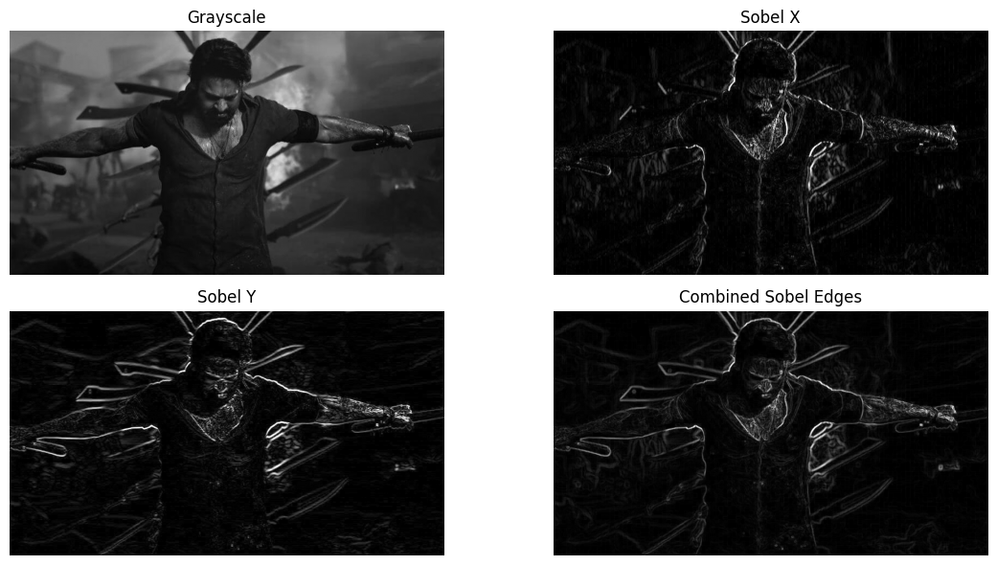

Ex17

import cv2
import matplotlib.pyplot as plt
from google.colab import files
import numpy as np

uploaded = files.upload()
filename = next(iter(uploaded))
img = cv2.imdecode(np.frombuffer(uploaded[filename], np.uint8), cv2.IMREAD_COLOR)

if img is None:
raise ValueError("Unable to read image.")

watermarked = img.copy()
text = "MY WATERMARK"
font = cv2.FONT_HERSHEY_SIMPLEX
scale = max(0.5, img.shape[1] / 1000)
thickness = max(1, int(scale * 2))

(text_w, text_h), baseline = cv2.getTextSize(
text, font, scale, thickness
)
x = max(5, img.shape[1] - text_w - 20)
y = max(text_h + 10, img.shape[0] - 20)
overlay = watermarked.copy()
cv2.putText(overlay, text, (x, y), font, scale,
(255, 255, 255), thickness + 2, cv2.LINE_AA)
cv2.putText(overlay, text, (x, y), font, scale,
(0, 0, 255), thickness, cv2.LINE_AA)
watermarked = cv2.addWeighted(overlay, 0.7, watermarked, 0.3, 0)
plt.figure(figsize=(10, 6))
plt.imshow(cv2.cvtColor(watermarked, cv2.COLOR_BGR2RGB))
plt.title("Watermarked Image")
plt.axis("off")
plt.show()
cv2.imwrite("watermarked_image.jpg", watermarked)
files.download("watermarked_image.jpg")



Ex18

import cv2
import matplotlib.pyplot as plt
from google.colab import files
import numpy as np
uploaded = files.upload()
filename = next(iter(uploaded))
img = cv2.imdecode(np.frombuffer(uploaded[filename], np.uint8), cv2.IMREAD_COLOR)
if img is None:
raise ValueError("Unable to read image.")
h, w = img.shape[:2]
# Select a central rectangular region
x1, y1 = w // 4, h // 4
x2, y2 = 3 * w // 4, 3 * h // 4
roi = img[y1:y2, x1:x2].copy()
result = img.copy()
# Paste the cropped region at the top-left corner
rh, rw = roi.shape[:2]
result[0:rh, 0:rw] = roi
cv2.rectangle(result, (x1, y1), (x2, y2), (0, 255, 0), 2)
plt.figure(figsize=(12, 5))
plt.subplot(1, 3, 1)
plt.imshow(cv2.cvtColor(img, cv2.COLOR_BGR2RGB))
plt.title("Original Image")
plt.axis("off")
plt.subplot(1, 3, 2)
plt.imshow(cv2.cvtColor(roi, cv2.COLOR_BGR2RGB))
plt.title("Cropped ROI")
plt.axis("off")
plt.subplot(1, 3, 3)
plt.imshow(cv2.cvtColor(result, cv2.COLOR_BGR2RGB))
plt.title("ROI Pasted")
plt.axis("off")
plt.tight_layout()
plt.show()

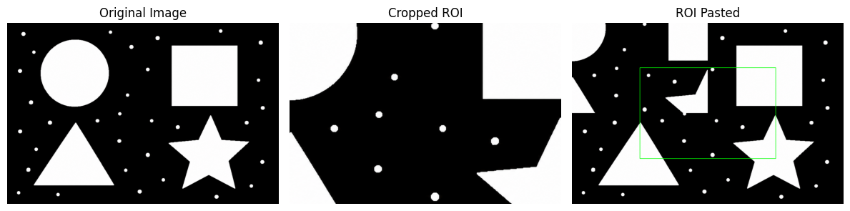

Ex19

import cv2
import matplotlib.pyplot as plt
from google.colab import files
import numpy as np
uploaded = files.upload()
filename = next(iter(uploaded))
img = cv2.imdecode(np.frombuffer(uploaded[filename], np.uint8), cv2.IMREAD_COLOR)
if img is None:
raise ValueError("Unable to read image.")
gray = cv2.cvtColor(img, cv2.COLOR_BGR2GRAY)
_, binary = cv2.threshold(gray, 127, 255, cv2.THRESH_BINARY)
kernel = cv2.getStructuringElement(cv2.MORPH_RECT, (5, 5))
result = cv2.morphologyEx(binary, cv2.MORPH_ERODE, kernel)
plt.figure(figsize=(10, 4))
plt.subplot(1, 2, 1)
plt.imshow(binary, cmap="gray")
plt.title("Original Binary")
plt.axis("off")
plt.subplot(1, 2, 2)
plt.imshow(result, cmap="gray")
plt.title("Morphological Erosion")
plt.axis("off")
plt.show()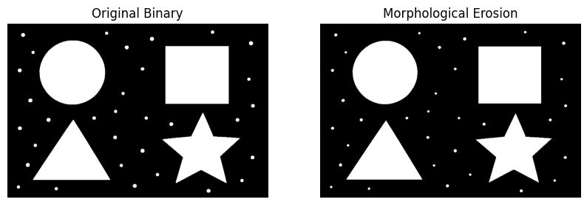

Ex20

import cv2
import matplotlib.pyplot as plt
from google.colab import files
import numpy as np

uploaded = files.upload()
filename = next(iter(uploaded))
img = cv2.imdecode(np.frombuffer(uploaded[filename], np.uint8), cv2.IMREAD_COLOR)

if img is None:
raise ValueError("Unable to read image.")

gray = cv2.cvtColor(img, cv2.COLOR_BGR2GRAY)
_, binary = cv2.threshold(gray, 127, 255, cv2.THRESH_BINARY)

kernel = cv2.getStructuringElement(cv2.MORPH_RECT, (5, 5))
result = cv2.morphologyEx(binary, cv2.MORPH_DILATE, kernel)

plt.figure(figsize=(10, 4))
plt.subplot(1, 2, 1)
plt.imshow(binary, cmap="gray")
plt.title("Original Binary")
plt.axis("off")
plt.subplot(1, 2, 2)
plt.imshow(result, cmap="gray")
plt.title("Morphological Dilation")
plt.axis("off")
plt.show()

